*Florida International University*

*School of Computing and Information Sciences*

Software Engineering Focus

Feature Document

User Story ID <810>

**Name: Add editing tools for solutions**

**Team Member(s):**

**Project: AR-VR-VE for Computer Science Education**

**Product Owner(s)**: Francisco Ortega

**Mentor(s)**: Francisco Ortega

**Instructor**: Masoud Sadjadi

**User Story Name: Add editing tools for solutions**

* Description: As a user I should be able to scroll when I have too many commands in my solution panel, change and delete commands so that I can update my entire solution without having to rewrite it.

Acceptance Criteria

* When user hovers over a command, a delete button appears
* When user hovers away from the command, the delete button disappears
* When the user clicks on the delete buttons, the command gets deleted
* When the user clicks on the trash icon, all commands in the solution panel get cleared
* When the checkmark button gets clicked, the player performs the according

**Use Case**

* Name: Player edits commands
* Actor: Player
* Preconditions: Player has entered commands and wants to edit them.
* Description <Player hovers over a command and a remove button appears, user can click on the remove button and the command gets removed from the solution panel. Player hovers over a command and an edit button appears, user can click on the edit button and the command gets swapped by whatever other . >:

**Use Case Diagram <**you can use draw.io**>**

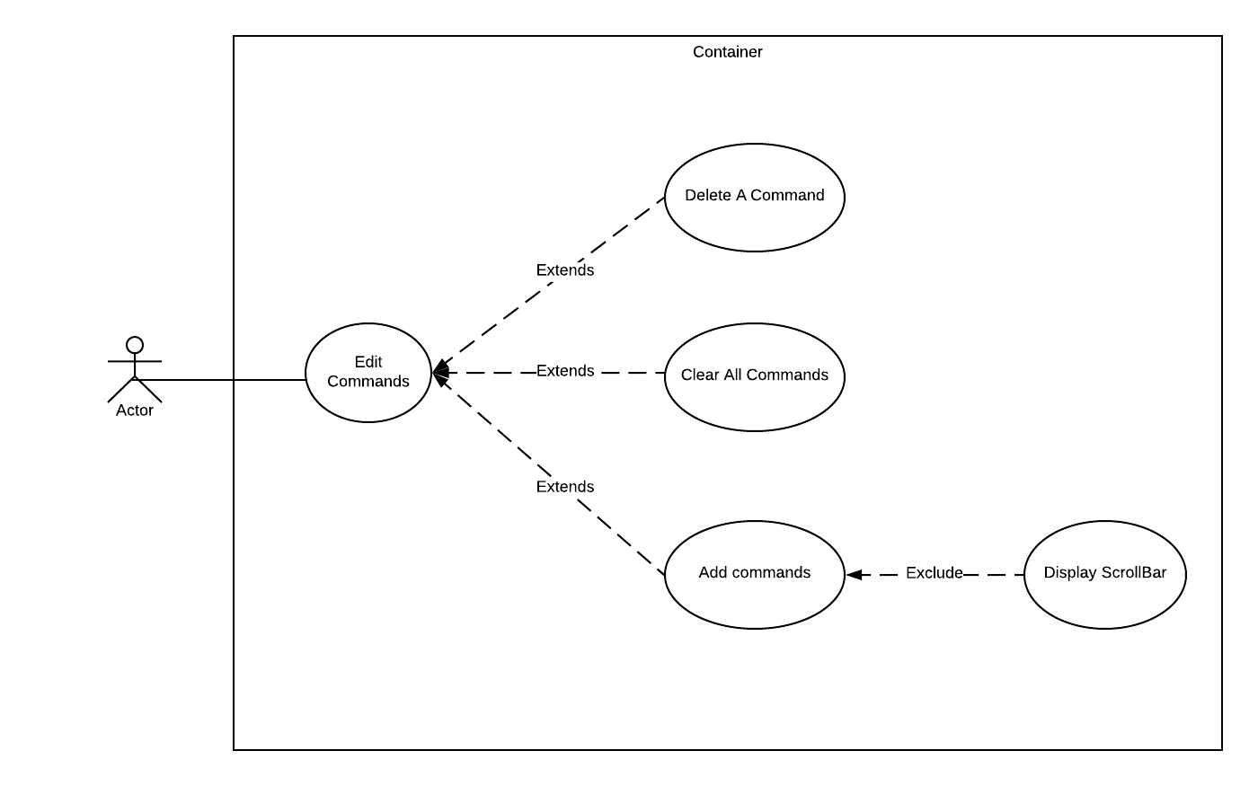

**Sequence Diagram**

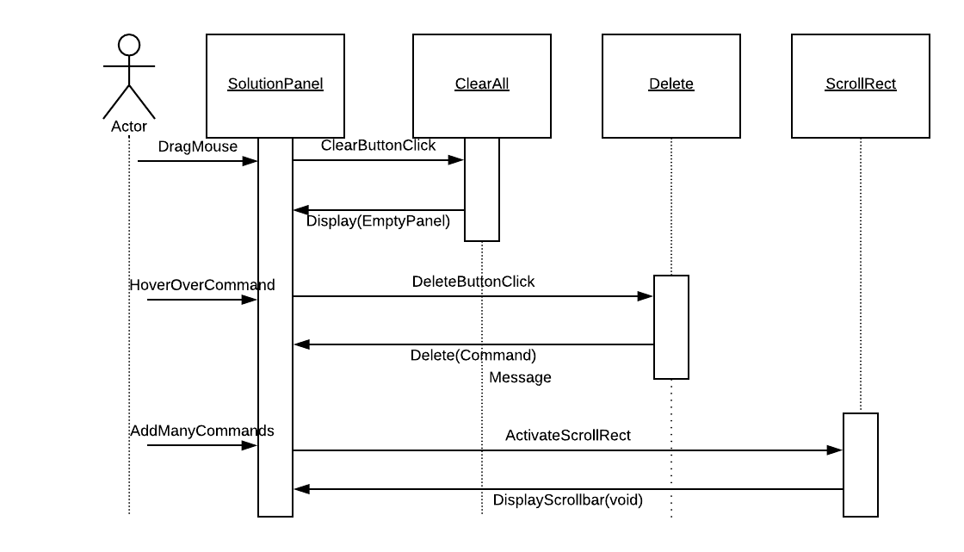

**Class Diagram**

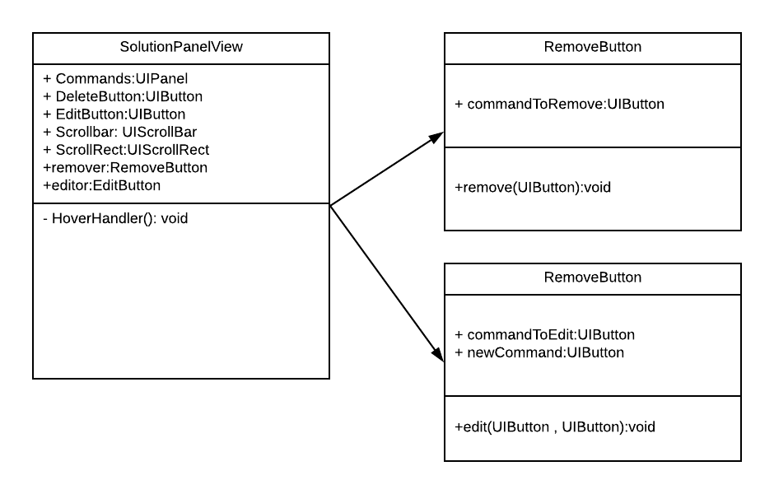

**Unit Test**

* Test case ID:
* Description/Summary of Test:
* Pre-condition:
* Expected Results:
* Actual Result:
* Status (Fail/Pass):

**Integration Test**

**Visual User Guide** <like one or two screenshots of the feature. For the hardware project, a photo of device is required>